**Project Title: Dockerizing Jenkins Pipeline**

**Note: This is a solution document on how the demonstration is performed on Docker 16.* version. Install the latest Docker version or >17.+ and Docker edge to allow multiple builds.**

Create a Dockerfile and add the following content to it:

FROM jenkins/jenkins:lts

USER root

RUN apt-get update && \  
apt-get -y install apt-transport-https \  
 ca-certificates \  
 curl \  
 gnupg2 \  
 software-properties-common && \  
curl -fsSL https://download.docker.com/linux/$(. /etc/os-release; echo "$ID")/gpg > /tmp/dkey; apt-key add /tmp/dkey && \  
add-apt-repository \  
 "deb [arch=amd64] https://download.docker.com/linux/$(. /etc/os-release; echo "$ID") \  
 $(lsb_release -cs) \  
 stable" && \  
apt-get update && \  
apt-get -y install docker-ce

RUN apt-get install -y docker-ce

RUN usermod -a -G docker jenkins

USER jenkins

Now build the file:

“docker build -t ubuntu .”

Since Jenkins is already installed in your system, start the Jenkins and login. Click on **New** **Item** and select **Pipeline**. Add the job name as **DockerizeJenkins.**

Add the script mentioned below:

pipeline {

environment {  
 registry = "docker_hub_account/repository_name"  
 registryCredential = 'dockerhub'  
 }

agent any

stages {  
 stage('Building image') {  
 steps{  
 script {  
 docker.build registry + ":$BUILD_NUMBER"  
 }  
 }  
 }  
 }  
}

Save the job.

Click on **Build Now** in the job menu of Jenkins. The job will fail as the error is due missing the source of Docker Hub file as shown below:

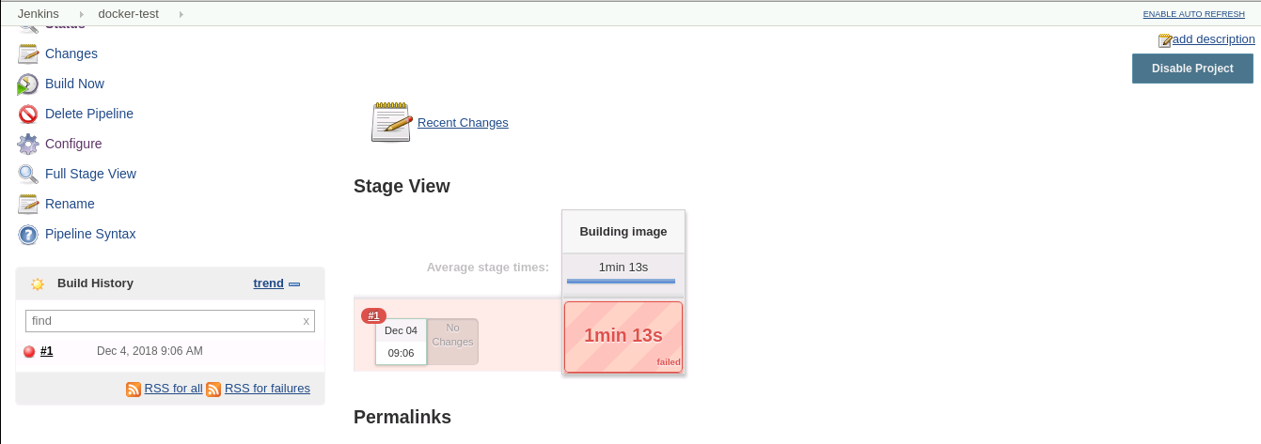

Since you have already created a Docker Hub account, login and click on “**Create** **Repository**”.

Go to Jenkins page and click on  **Credentials** → **Global** → **Add Credentials**

Add your Docker Hub credentials and save it. ID and Description should be “**dockerhub”.**

Also, a Git repository should be cloned in order to use a Node.js application as an example.

Add the image in Docker registry to pull in other machines.

Now change the script in the Jenkins Pipeline as given below. Replace **docker_hub_account** with your Docker Hub account name and **repository_name** with the repository you have created. The final script code will be:

pipeline {  
 environment {  
 registry = “docker_hub_account/repository_name”  
 registryCredential = ‘dockerhub’  
 dockerImage = ‘’  
 }  
 agent any  
 stages {  
 stage(‘Cloning Git’) {  
 steps {  
 git ‘https://github.com/SimplilearnDevOpsOfficial/DockerizeJenkins.git '  
 }  
 }  
 stage(‘Building image’) {  
 steps{  
 script {  
 dockerImage = docker.build registry + “:$BUILD_NUMBER”  
 }  
 }  
 }  
 stage(‘Deploy Image’) {  
 steps{  
 script {  
 docker.withRegistry( ‘’, registryCredential ) {  
 dockerImage.push()  
 }  
 }  
 }  
 }  
 }  
}

Complete the pipeline to the Node.js application:

Go to Manage Jenkins → Manage Plugins → Available. Then, search for **NodeJs**. Check the box and click on  **Download now and install after restart.**

Now configure the Node.js tool.

Go to Jenkins home → Manage Jenkins → Global Tool Configuration and search for **NodeJs**.

Name it as **node** and select any 9+ version from the dropdown.

The final script code will be:

pipeline {  
 environment {  
 registry = “docker_hub_account/repository_name”  
 registryCredential = ‘dockerhub’  
 dockerImage = ‘’  
 }  
 agent any  
 tools {nodejs “node” }  
 stages {  
 stage(‘Cloning Git’) {  
 steps {  
 git ‘https://github.com/SimplilearnDevOpsOfficial/DockerizeJenkins.git '  
 }  
 }  
 stage(‘Build’) {  
 steps {  
 sh ‘npm install’  
 sh ‘npm run bowerInstall’  
 }  
 }  
 stage(‘Test’) {  
 steps {  
 sh ‘npm test’  
 }  
 }  
 stage(‘Building image’) {  
 steps{  
 script {  
 dockerImage = docker.build registry + “:$BUILD_NUMBER”  
 }  
 }  
 }  
 stage(‘Deploy Image’) {  
 steps{  
 script {  
 docker.withRegistry( ‘’, registryCredential ) {  
 dockerImage.push()  
 }  
 }  
 }  
 }  
 }  
}

Before you build the application, provide the directory level access to Jenkins and Docker.

“sudo usermod -a -G docker jenkins”

Now click on **Build.** You should be able to view that Jenkins is working with Docker through different stages.

